Secondary Social Studies Skills

Diagnostic Exam
Name: Date:

Standard 1: Identify cardinal and intermediate directions.

Directions: Choose the BEST answer.

1. ____ North, South, East and West are examples of what type of direction?
a) cardinal b) intermediate c) direct d) indiscreet

2. ____Northeast, Northwest, Southeast and Southwest are examples of what type of direction?
a) cardinal b) intermediate c) direct d) indiscreet

3. ____ If you are facing the north pole, which direction is to your right?
a) north b) south c) east d) west

Directions: Use the word bank provided below to label the parts of the compass.

Word Bank: north east south west

- _____________

5. _______________
- ____________

6. _______________

Directions: Use the word bank provided below to label the parts of the compass.

Word Bank: northeast northwest southeast southwest

- _____________

9. _______________
- ____________

10. _______________

Standard: Identify the four hemispheres
Directions: Use the terms in the word bank to label the hemispheres.

Word Bank: Northern Hemisphere Southern Hemisphere

Eastern Hemisphere Western Hemisphere
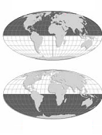
11._________________

12._________________

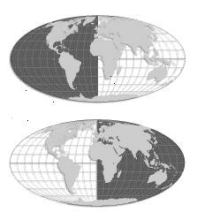

13._______________

14._________________

Map from:www.worldatlas.com/aatlas/imageh.htm

Directions: Use the map provided to answer questions 15 and 16.

15. ____ Which hemisphere is Australia in?
a) northern hemisphere b) southern hemisphere
c) eastern hemisphere d) western hemisphere

16. ____ Which hemisphere is New York in?
a) northern hemisphere b) southern hemisphere
c) eastern hemisphere d) western hemisphere

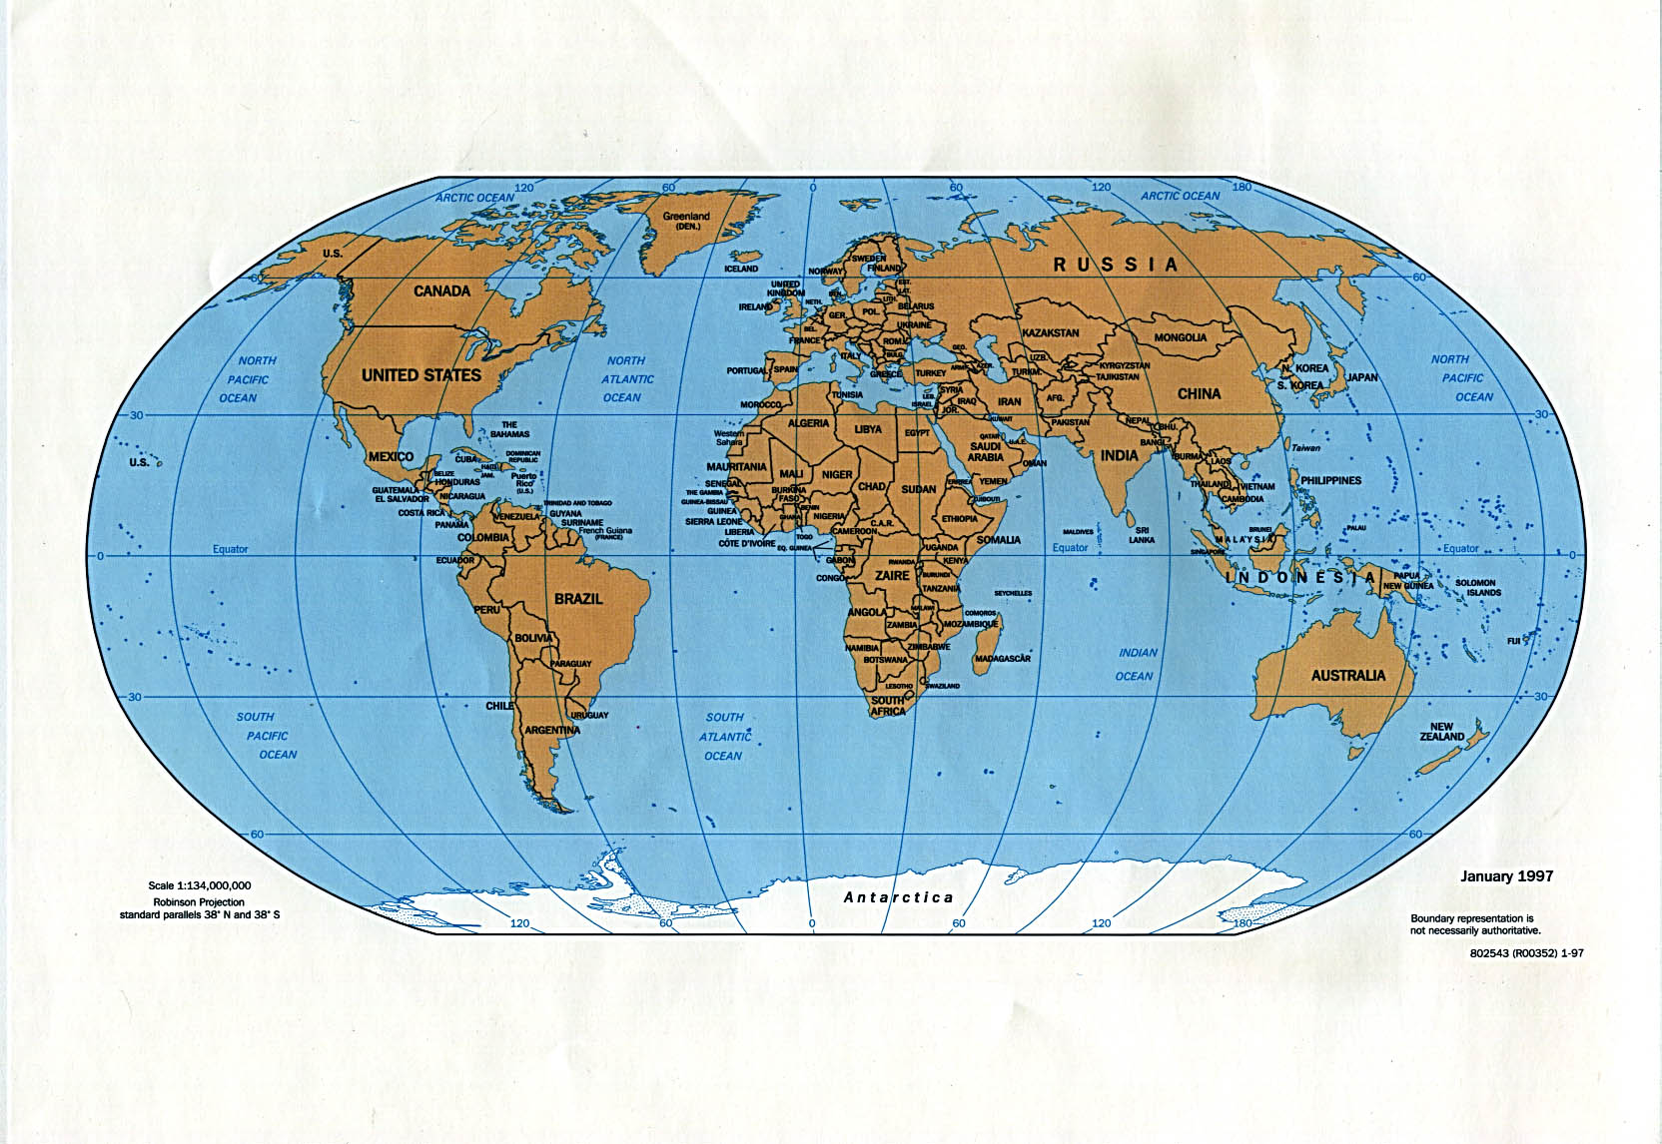

Map from: http://ftp.lib.utexas.edu/maps/world_maps/world_pol97.jpg

Standard: Identify lines of latitude and longitude.

Directions: Choose the BEST answer.

17. ____ Latitude lines are used to measure from ____________
a) north to south b) east to west c) west to north d) south to east

18. ____ Longitude lines are used to measure from ___________
a) north to south b) east to west c) west to north d) south to east

Directions: Match the letter on the map with the term in the question.

Word Bank: Equator Prime Meridian Tropic of Cancer Tropic of Capricorn

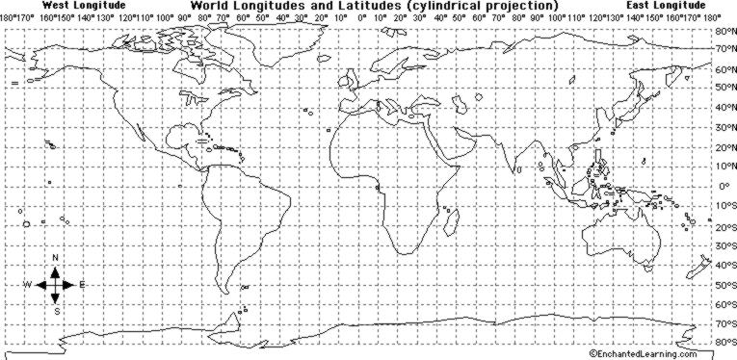

Map from: http://www.jamesverhoeven.com/maps/lat%20and%20long.jpg

19. ____ Equator
20. ____ Prime Meridian
21. ____ Tropic of Cancer
22. ____ Tropic of Capricorn

Directions: Choose the BEST answer.

22. ____ The equator is the same as:
a) 0’ longitude b) 0’ latitude c) 90’ latitude d) 90’ longitude

23. ____ The prime meridian is the same as:
a) 0’ longitude b) 0’ latitude c) 90’ latitude d) 90’ longitude

24. ____ If you start on the prime meridian and move to the right, which direction are you heading?
a) north b) south c) east d) west

25. ____If you start on the equator and move up, which direction are you heading?
a) north b) south c) east d) west

Standard: Use latitude and longitude lines to locate points on a map.

Directions: Find the country using the latitude and longitude points provided. Write the name of the country in the space provided.
Russia

USA
Mexico
Brazil
South Africa
Australia

Map from: http://www.jamesverhoeven.com/maps/lat%20and%20long.jpg

- 40’ N, 100’ E __________________________

- 10’ S, 50’ E __________________________

- 30’ S, 30’ N __________________________

- 60’ N, 100’ W __________________________

Standard: Locate and identify the 7 continents and 4 oceans.

Directions: Label the seven continents using the map below.

Word Bank: Africa Antarctica Asia Australia Europe North America South America

30. ________________ 31. ________________________

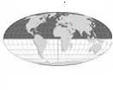

32. _____________ 33. _________________

Map from:www.worldatlas.com/aatlas/imageh.htm

34 ___________________ 35. ______________________ 36. ___________________

Directions: Label the four oceans using the map below.

Word Bank: Atlantic Indian Pacific Arctic

37. __________________________ 38. _____________________________

Map from:www.worldatlas.com/aatlas/imageh.htm

39. __________________________ 40. _____________________________
Standard: Define major landforms.

Directions: Write the letter of the landform next to the correct definition.

a) mountain b) valley c) peninsula d) river delta e) mountain range
f) plain g) island h) archipelago i) plateau k) harbor

- _____ a low area between two mountains
- _____ a area at the end of a river where rich soil is sometimes found
- _____ a large, flat, open area of land.
- _____ a group of islands
- _____ a piece of land completely surrounded by water
- _____ a high, flat are of land
- _____ a chain of mountains
- _____ a safe protected area of water where ships can dock safely
- _____ a landform with steep sides and a high elevation.
- _____ a piece of land surrounded by water on three sides.

Standard: Explain the factors that effect climate.

Directions: Choose the BEST answer.

51. ____ As you elevation increases, temperature….
a) increase b) decreases c) remains the same

52. ____ As you move closer to an ocean, the winters usually will become
a) cooler b) warmer c) remain the same

53. ____ As you move away from the equator, the temperature will usually
a) increase b) decreases c) remains the same

54. ____ As you move away from the poles, the temperature will usually
a) increase b) decreases c) remains the same

55. ____ In the tropics, the temperature is usually…
a) about the same all year b) changes each season
c) is much warmer in the summer than the winter

Standard: Be able to use various sources to obtain information.

56. ____ If you want to find where one topic is located in a book where would you look?
a) the index b) the glossary c) the table of contents

57. ____If you want to find the definition of a word in a book, where would you look?
a) the index b) the glossary c) the table of contents

58.____ If you want to find the page a chapter starts on, where would you look?
a) the index b) the glossary c) the table of contents

59.____ A newspaper, a letter and a poster are all examples of a ….
- secondary source b) a primary source c) an almanac d) a dictionary

60.____ A text book and a non-fiction text are both examples of a ….
- secondary source b) a primary source c) an almanac d) a dictionary

61.____ If you wanted to find information about climate or facts about a place, where would you look?
a) thesaurus b) dictionary c) an almanac d) an encyclopedia

62.____ If you wanted to find the definition of a word, where would you look?
a) thesaurus b) dictionary c) an almanac d) an encyclopedia

63.____ If you wanted to find words with similar meanings, where would you look?
a) thesaurus b) dictionary c) an almanac

Standard: Identify the uses for a political and physical map.

64.____ If you wanted to find a county or a town on a map, what type of map would you use?
a) physical map b) political map c) globe d) Robinson projection

65.____ If you wanted to see the geography or find the landforms in a place, what type of map would you use?
a) physical map b) political map c) globe d) Robinson projection

