UNIT 2 ASSESSMENT

STUDENT CONSTRUCTED DBQ’S

Primary sources should be available for students and they therefore choose a section of such works and create document based questions out of this information. They can develop document based questions on texts, political cartoons, charts, graphs, photographs, or maps. The following are examples of what the students can create, or they can be used as a back up assessment if you feel your students would benefit more from text book style assessments at this time.

You can add questions to these documents to use them as an assessment, or allow students again to create their own questions based on these documents, or even more in depth you can have students find these images and texts online using google and google images, or history textbooks or sources within the classroom. The five pillars, the caste system, and the 5 relationships of Confucius are all available in the text book.

Document 1:
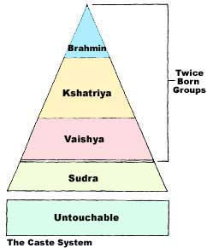

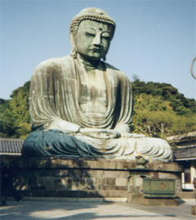

Document 2

Document 3

- To bear witness that there is none worthy of worship save Allah and that Muhammad (peace and blessings of Allah be upon him) is the Messenger of Allah.
2. To observe Prayer (Salat).
3. To Pay Zakat (Alms giving)
4. To perform the Pilgrimage to the House of Allah (Hajj).
5. To Observe fasting during Ramadhan." (Bukhari)

Document 4

For God so loved the world that he gave his one and only Son,^{[a]} that whoever believes in him shall not perish but have eternal life. For God did not send his Son into the world to condemn the world, but to save the world through him. Whoever believes in him is not condemned, but whoever does not believe stands condemned already because he has not believed in the name of God's one and only Son.^{[a}This is the verdict: Light has come into the world, but men loved darkness instead of light because their deeds were evil.

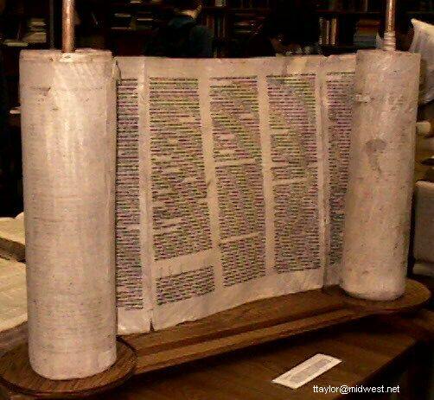
Document 5

Document 6
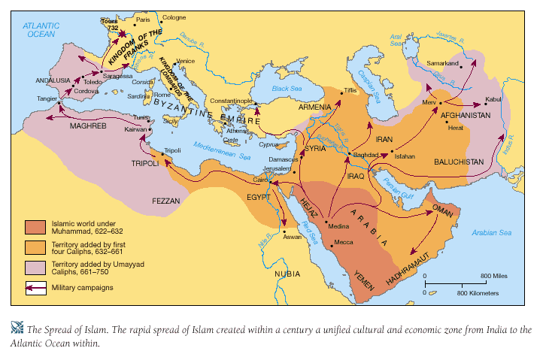

Document 7

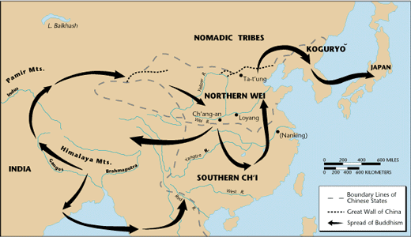

Document 8

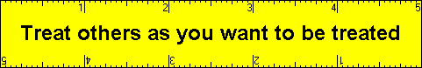

Document 9

• The Master said about government, “Encourage the people to work hard by setting an example yourself. Do not allow your efforts to slacken.” 13:1
- “…Being good as a son and obedient as a young man is, perhaps, the root of a man’s character.” 1:2
- “A gentleman makes friends through being cultivated, but looks to friends for support in benevolence (goodwill).” 12:24
- “Small change starts at home and then spreads throughout the world”
- “Everything living thing has beauty, but not everyone is lucky enough to see it”

Document 10

a Message from Allah to humanity. It was transmitted to us in a chain starting from the Almighty Himself (swt) to the angel Gabriel to the Prophet Muhammad (saas). This message was given to the Prophet (saas) in pieces over a period spanning approximately 23 years (610 CE to 622 CE).

Document 11
Plants and trees have been considered sacred by themselves because, as some have thought, they are home to certain spirits. Both the soma plant of India and the coca shrub of Peru are worshiped for the intoxicating properties of the products made from them. Field crops, thought to harbor spirits of infertility, has been honored by ancient tribesmen and peasants throughout Europe. Traces of these cults can still be found.
The above describes nature worshipers among which many occultists are numbered. They view life as being in everything, and everything, even man, supporting life. Life is sacred -- all life. "One of the foremost characteristics of Neo-Paganism (or occultism) is the return to the ancient idea that there is no distinction between the spiritual and material, sacred and secular." Everything is still one as it was to primitive man.

