UNIT 1 ASSESSMENT

DBQ CREATION

Purpose: The purpose of this assessment is to familiarize students with primary sources and document based questions not to mention perhaps the most significant documents in the history of the United States. The more students deal with document based questions throughout the year, the less stumped they are on the Regents come June.

DBQ’s come in a variety of forms ranging from pictures, graphs, charts, texts, to maps and political cartoons. You can use any of these things to create DBQ questions, the question remaining is where do you find the stuff for these questions? Try online using google and google images. You can then use these sources to create questions and piece together an entire dbq test as seen below.

Document 1: The Articles of Confederation
Article I. The Stile of this Confederacy shall be "The United States of America
Article II. Each state retains its sovereignty, freedom, and independence, and every power, jurisdiction, and right, which is not by this Confederation expressly delegated to the United States, in Congress assembled.
Article III. The said States hereby severally enter into a firm league of friendship with each other, for their common defense, the security of their liberties, and their mutual and general welfare, binding themselves to assist each other, against all force offered to, or attacks made upon them, or any of them, on account of religion, sovereignty, trade, or any other pretense whatever.
Article IV. The better to secure and perpetuate mutual friendship and intercourse among the people of the different States in this Union, the free inhabitants of each of these States, paupers, vagabonds, and fugitives from justice excepted, shall be entitled to all privileges and immunities of free citizens in the several States; and the people of each State shall free ingress and regress to and from any other State, and shall enjoy therein all the privileges of trade and commerce, subject to the same duties, impositions, and restrictions as the inhabitants thereof respectively, provided that such restrictions shall not extend so far as to prevent the removal of property imported into any State, to any other State, of which the owner is an inhabitant; provided also that no imposition, duties or restriction shall be laid by any State, on the property of the United States, or either of them.
Full faith and credit shall be given in each of these States to the records, acts, and judicial proceedings of the courts and magistrates of every other State.
- According to this document what rights do the states maintain over the central government?

- Why were the states in a friendly alliance with one another?

Document 2: Shays Rebellion

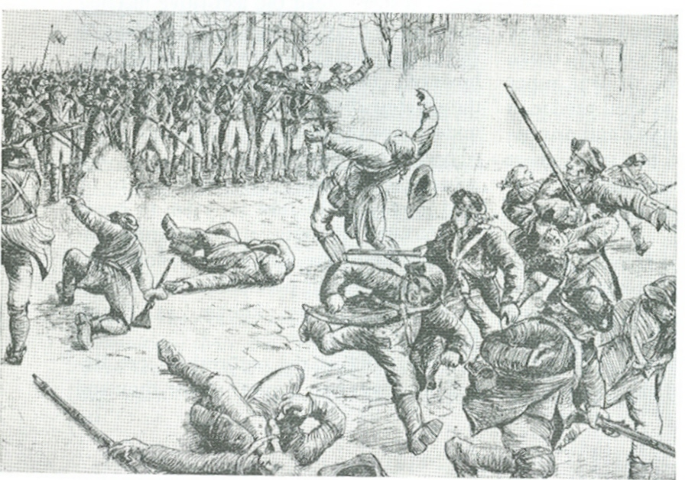

- What were the effects of the event captured in the picture above?

- How was this event cause a chain reaction evident throughout the study of American History?

Document 3: Preamble of the Constitution

We the People of the United States, in Order to form a more perfect Union, establish Justice, insure domestic Tranquility, provide for the common defense, promote the general Welfare, and secure the Blessings of Liberty to ourselves and our Posterity, do ordain and establish this Constitution for the United States of America.

- According to this document why was the constitution created?

- What is the purpose of the preamble?

Document 4:

I: Congress shall make no law respecting an establishment of religion, or prohibiting the free exercise thereof; or abridging the freedom of speech, or of the press; or the right of the people peaceably to assemble, and to petition the Government for a redress of grievances.

II: A well regulated Militia, being necessary to the security of a free State, the right of the people to keep and bear Arms, shall not be infringed.

X: The powers not delegated to the United States by the Constitution, nor prohibited by it to the States, are reserved to the States respectively, or to the people.

- What do all of the sections of this document have in common?

- Where did this information come from, or what is the document itself called?

- What is the purpose of this document?

Document 5:
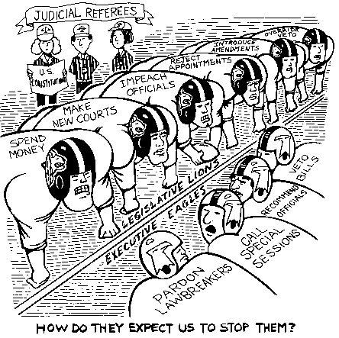

- What court case in United States history is exemplified in this political cartoon?
- According to this cartoon what is the responsibility of the judicial branch

- What was the final decision in the US court case depicted above? Why did it matter?

Document 6: The Constitutional Convention
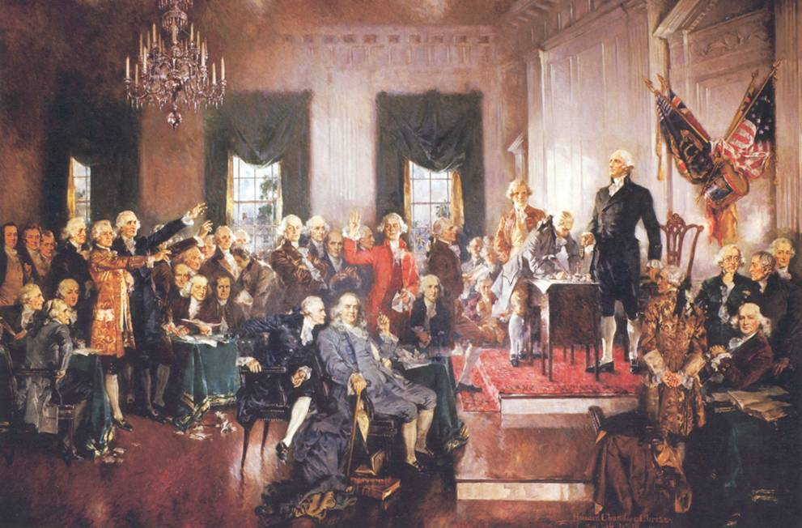

- Name three people who would have been in attendance during the event pictured above?

- Why was this convention called? For what purpose?

Document 7:
12/19/05 Bush admits to authorizing domestic spying
The President and members of his Cabinet admitted over the weekend that reports that he had authorized secret spying on U.S. citizens were true. The reports were partially to blame for Friday's failure of key provisions of the Patriot Act to be reauthorized by the Congress. Bush said that he authorized the NSA to secretly wiretap U.S. citizens by Executive Order, and has reauthorized the order over 30 times since the original. Democrats were "stunned" by the revelation. Bush said that he was surprised the secret Executive Order was revealed by the press, calling it "a shameful act."

- Why is this document problematic for the American people?
- What would the framers have to say about the authorization of the domestic spying by the chief executive of the United States of America?

