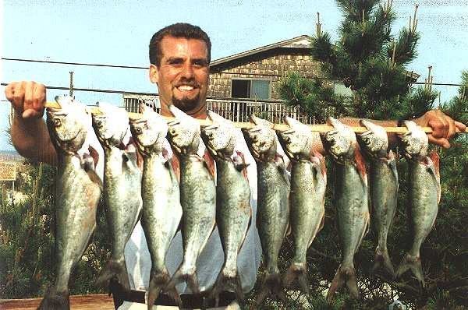
ESTIMATING FISH POPULATIONS

Fish biologists need to keep track of fish populations in the waters they monitor. They want to know, for example, how many rainbow trout are there in Lake Placid. This number changes, however, throughout the year as fish move in and out. Therefore biologists need a way to gather current data fairly quickly and inexpensively.

Since it is impossible to count every animal, biologists use the “tag and recapture” process to help them estimate the size of a population. Tag and recapture involves collecting a sample of animals, tagging them, and releasing them back into the wild. Later, biologists collect a new sample of the animals and count the number in the sample distinguishing between the first time captures and recaptures. They then use ratios to estimate the population size.

Each team has a lake (paper sack) full of fish (beans) and a net (a small cup). Be sure each team member records all the team’s data, calculations and conclusions.

OVERVIEW
We will be trying to estimate the number of fish in the lake the way the department of Fish and Game does. Here is a preview of this simulation:
1. Collect an initial sample. Count and tag the specimens.
2. Return the tagged sample to the lake.
3. Collect an additional sample. Count the number of tagged and untagged fish.
4. Use the data (counts) to write proportions.
5. Solve the ratios to find the lake population.

When you finish these steps, you will have three pieces of data to help you calculate the fourth:
1. “Total number of tagged fish in the lake,”
2. “Number of tagged fish in the sample,” and
3. “Total number of fish in the sample.” Now solve for the fourth:
4. “Total number of fish in the lake.”

Name: ________________________________________ January 19, 2006

This investigation is a simulation of the process (tag and release) used by Fish & Game Scientists to estimate the number of fish in a lake.

Be sure that each team member records all the team’s data, calculations and conclusions.

Data that you will collect:
1. Total number of tagged fish in the lake
2. Number of tagged fish in the sample
3. Total number of fish in the sample

Write an equation that incorporates the above data pieces into a proportion:

__________________ = _________________
total number of
fish in the lake

Use the following table to organize the data that you collect:
Trial | Number of Tagged Fish in Sample | Total Number of Fish in Sample | Estimate for the Total Number of Fish in the Lake
1
2
3
Total Number of tagged fish in the lake: _________

Procedure:

Tagging the Initial Sample
1. Use your “net” to collect a sample (cupful) of fish (beans) from the lake.

2. Count the number of fish you netted in your sample. To “tag” the netted fish, replace each one with a red fish (red bean). Record the number of tagged fish as the “total number of tagged fish” (under the table).

3. Put all the tagged fish back into the lake. Be careful not to let any of the fish jump out onto the floor. Gently shake the bag to thoroughly mix all the fish in the lake. Try not to bruise them.

Collecting a Sample
4. Use your net to take out another cupful of fish. Count and record the “total number of fish in sample” for Trial 1 in the table.

5. Count and record the “number of tagged fish in sample” for Trial 1.

Estimating the Population
6. You now have three pieces of information: the total number of tagged fish in the lake, the number of tagged fish in the sample and the total number of fish in sample.

Use this information to write two equivalent ratios. Then use the equation you wrote to estimate the total number of fish in the lake.
Show your work:

Your estimate for the total number of fish in the lake: ___________

7. Return your sample of fish to the lake. Gently mix the fish. Take another sample. Repeat the counting and recording procedures of number 4 and 5. Record data in table for Trial 2. Use the new information to write a proportion as in number 6. Solve the equation.
Show your work:

Your second estimate for the total number of fish in the lake: _____________

You may perform a third trial if you have time. Record your data in the table.

You may average your estimates to come up with one estimate for the total number of fish in the lake. __________________

8. Count the fish in your lake to find the actual population. Record the actual population.

The actual number of fish in the lake: _____________

9. Was your estimate close? If not, what might have thrown it off? What do you think of this method for estimating fish populations?

