A commercial artist plans to include an ellipse in a design and wants the length of the horizontal axis to equal 10 and the length of the vertical axis to equal 6. Which equation could represent this ellipse?
(1) (3)
(2) (4)

Which equation, when graphed on a Cartesian coordinate plane, would best represent an elliptical racetrack?
(1) (3)
(2) (4) $\text{30}\text{xy}=\text{288},\text{000}$

An object orbiting a planet travels in a path represented by the equation $3(y+1)^{2}+5(x+4)^{2}=\text{15}\text{.}$ In which type of pattern does the object travel?
(1) hyperbola (3) circle
(2) ellipse (4) parabola

The accompanying diagram represents the elliptical path of a ride at an amusement park.
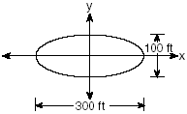
Which equation represents this path?
(1) (3)
(2) (4)

The accompanying diagram shows the elliptical orbit of a planet. The foci of the elliptical orbit are and .
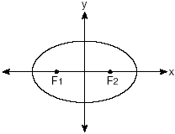
If a, b, and c are all positive and which equation could represent the path of the planet?
(1) (3)
(2) (4)

An architect is designing a building to include an arch in the shape of a semi-ellipse (half an ellipse), such that the width of the arch is 20 feet and the height of the arch is 8 feet, as shown in the accompanying diagram.
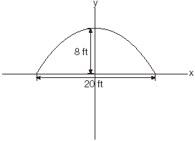
Which equation models this arch?
(1) (3)
(2) (4)

The accompanying diagram shows the construction of a model of an elliptical orbit of a planet traveling around a star. Point P and the center of the star represent the foci of the orbit.
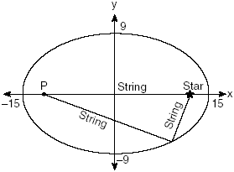
Which equation could represent the relation shown?
(1) (3)
(2) (4)

