Mathematics Performance Indicator - 2006

Instructions: Show all your work on the paper provided.
Circle the correct choice on this paper AND bubble the correct choice on the scantron sheet provided.

Student Name: Current School:

- Maria got scores of 95, 70, and 65 on three tests. What score does she need on her next test so that the mean (average) of her test grades will be at least an 80?
(A) 80 (B) 85 (C) 89
(D) 92 (E) None of these

- When x = −3, the value of $5−x^{2}−2x$ is:
(A) 5 (B) 2 (C) 20
(D) −10 (E) None of these.

- In the diagram below, what are the coordinates of point A?

(A) (-1,3) (B) (3,-1) (C) (-3,1)
(D) (1,-3) (E) None of these

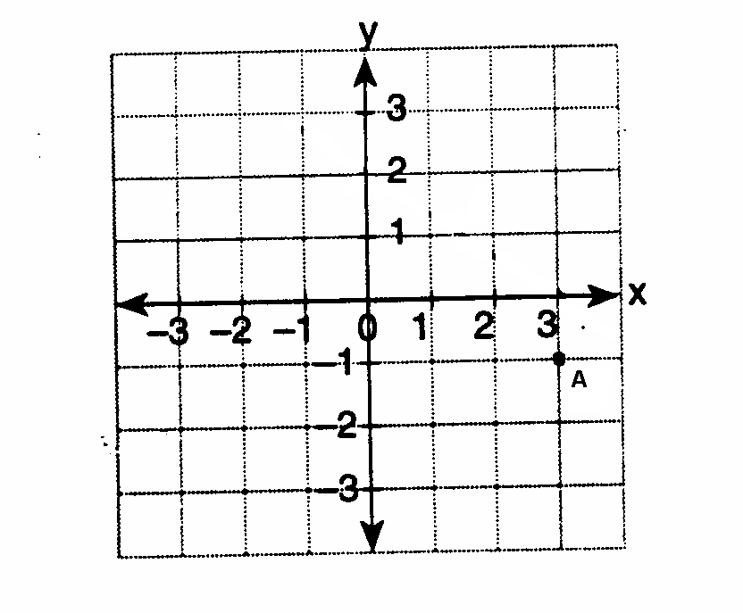
- Solve for the value of x: $6x−6=−\text{30}$
(A) -6 (B) -4 (C) 6
(D) 4 (E) None of these

- A movie rental club charges a monthly membership of $15 and a rental charge of $2 per movie. If n represents the number of movies rented in May, then the charge for this month can be represented by:
(A) 15n (B) 2n + 15 (C) 17n
(D) 30n (E) None of these

- Solve for the value of x: 5x + 24 – 3x = 0
(A) 2 (B) 3 (C) 5
(D) 9 (E) None of these

- A girl can ski down a hill five times as fast as she can climb up the same hill. If she can climb up the hill and ski down in a total of 9 minutes, how many minutes does it take her to climb up the hill?
(A) 1.5 (B) 7.2 (C) 4.5
(D) 7.5 (E) None of these

- Solve for the value of x: $4(x+8)=\text{28}$
(A) 15 (B) 9 (C) 5
(D) -1 (E) None of these

- If 30% of a number equals 36, what is the number?
(A) 10.8 (B) 30 (C) 96
(D) 120 (E) None of these

- If your height increases from 40 inches to 50 inches, which of the following represents the percent increase in your height?
(A) 10 (B) 20 (C) 25
(D) 80 (E) None of these

- If six pair of socks cost $8, how many pairs of socks can be purchased for $12?
(A) 4 (B) 9 (C) 10
(D) 16 (E) None of these

- If 9x + 2a = 3a – 4x, then x equals
(A) a (B) – a (C)
(D) (E) None of these

- There are 461 students and 20 teachers taking a bus to a museum. Each bus seats a maximum of 52 passengers. What is the least number of buses needed for the trip?
(A) 8 (B) 10 (C) 9
(D) 11 (E) None of these

- What is the slope of line ℓ in the accompanying diagram?
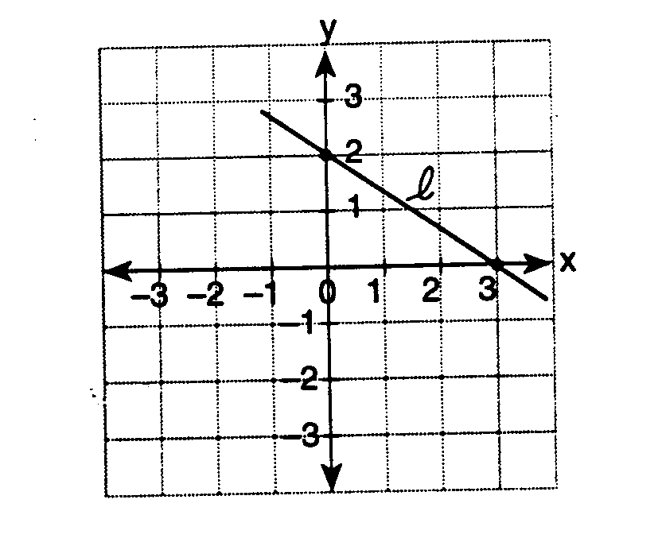
(A) (B) (C) (D) (E) None of these

- What is the value of the y-intercept of the graph of the line y = 3x – 6 ?

(A) 3 (B) – 2 (C) – 5
(D) – 6 (E) None of these

- Solve the following system of equations for x:
2x + y = 3
x + y = 9
(A) 12 (B) 6 (C) −6 (D) 4
(E) None of these

- Which equation represents the axis of symmetry of the parabola: $y=2x^{2}−8x+5$?
(A) x =2 (B) x = 4 (C) x = −2
(D) x = −4 (E) None of these

- Multiply: $(5x^{3}y^{2})(4{\text{xy}}^{5})$
(A) $9x^{3}y^{\text{10}}$ (B) 9x⁴y⁷ (C) 20x⁴y⁷
(D) 20x³y¹⁰ (E) None of these

- In triangle ABC, angle B is a right angle.
Find the length of .
6

A
B
C
10

(A) 4 (B) 16 (C) $2\sqrt{\text{34}}$
(D) $\text{34}\sqrt{2}$ (E) None of these

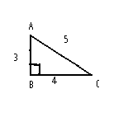
- Using the diagram below, select the choice that represents the cosine of angle A.
(A) $\frac{3}{4}$ (B) $\frac{4}{3}$
(C) $\frac{3}{5}$ (D) $\frac{4}{5}$
(E) None of these

- Add $\sqrt{3}+\sqrt{\text{75}}$
(A) $5\sqrt{3}$ (B) $\sqrt{\text{78}}$ (C) $6\sqrt{3}$
(D) $4\sqrt{3}$ (E) None of these

- Simplify: $6x^{3}−(2x−4x^{3})$
(A) –10x³ – 2x (B)$\text{10}x^{6}−2x$ (C) 2x³ – 2x
(D) 2x⁶ – 2x (E) None of these

- Which of these is equal to: $(x−3)(2x+4)$
(A) $2x^{2}+2x+\text{12}$ (B) $2x^{2}+2x−\text{12}$
(C) $2x^{2}−2x+\text{12}$ (D) $2x^{2}−2x−\text{12}$
(E) None of these

- One of the factors of 4x² − 9 is
(A) (x + 3) (B) (4x + 3) (C) (2x + 3)
(D) (x − 3) (E) None of these

- Solve for the values of x: $x^{2}−x−\text{12}=0$
(A) {-2, 6} (B) {2, -6} (C) {-3, 4}
(D) {3, -4} (E) None of these

- Simplify: $\frac{8x^{3}+6x}{2x}$

(A) $4x^{2}+3x$ (B) $4x^{3}+3$ (C) $6x^{2}+3x$
(D) $4x^{2}+3$ (E) None of these

- Simplify: $\frac{1}{2}−\frac{x}{y}$
(A) $\frac{2x−y}{2y}$ (B) $\frac{y−2x}{2y}$ (C) $\frac{x−1}{2y}$
(D) $\frac{x−1}{y−2}$ (E) None of these

