We Real Cool

The Pool Players.
Seven at the Golden Shovel.

We real cool. We
left school. We
Lurk late. We
Strike straight. We
Sing sin. We
Thin gin. We
Jazz June. We
Die soon.

1. In this poem, the word lurk probably means

A sleep
B creep around
C time
D go to school

Jack Sprat by Lois Muehl
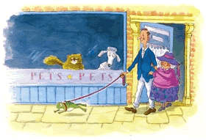

Jack Sprat would have no cat
his wife would have no dog.
So when they went to buy a pet,
they settled on a hog.

2. In this poem, the word settled means

A decided
B sat
C bought
D chose
Be Glad Your Nose is on Your Face
by Jack Prelutsky

Be glad your nose is on your face,
not pasted on some other place,
for if it were where it is not,
you might dislike your nose a lot.

Imagine if your precious nose
were sandwiched in between your toes,
that clearly would not be a treat,
for you'd be forced to smell your feet.

Your nose would be a source of dread
were it attached atop your head,
it soon would drive you to despair,
forever tickled by your hair.

Within your ear, your nose would be
an absolute catastrophe,
for when you were obliged to sneeze,
your brain would rattle from the breeze.

Your nose, instead, through thick and thin,
remains between your eyes and chin,
not pasted on some other place--
be glad your nose is on your face!

3. The definition of the word dislike is

A really like
B not like
C love
D disrespect

4. A synonym for sandwiched is

A dropped
B pasted
C inserted
D eaten

5. The word dread probably means

A anxiety
B hope
C annoying
D hate

6. In this poem, the word catastrophe means

A storm
B pain
C itchy
D disaster

