Remembering Rosa Parks
Her bravery sparked a fight for civil rights

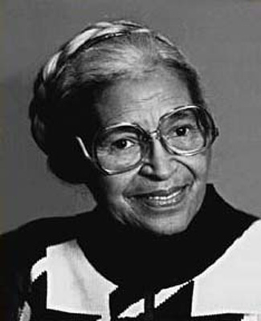
Fifty years ago, civil rights pioneer Rosa Parks quietly opened a new chapter in our nation's history. Parks died last Monday at her home in Detroit, Michigan. She was 92 years old. The world mourns the loss of a leader who took a stand by taking a seat.
On December 1, 1955, Parks broke the law. Her crime was to take an empty seat on a public bus in Montgomery, Alabama. It's an act that doesn't seem special at all today. But in 1955, segregation laws in some states required separate seating for blacks and whites in restaurants, on buses and in other public spaces. Parks stood for racial equality by refusing to move when a white man wanted her to give up her seat.
Parks was arrested, but her act of bravery set off a chain of events that changed the United States. African Americans responded to the injustice by refusing to ride buses in Montgomery. Martin Luther King Jr. led the peaceful boycott, which lasted 381 days. In 1956, the U.S. Supreme Court ruled that African Americans could not be forced to sit only in certain areas on buses. And in 1964, the Civil Rights Act outlawed racial discrimination in all public places.
Many admirers call Parks the mother of the civil rights movement. She led by example, showing that peaceful protest could create dramatic change. But Parks shared the credit. "The only thing that made it significant was that the masses of the people joined in," she said.

Write a sentence or two that sums up the main idea of the passage (What? and So What?)

________________________________________________________________________

________________________________________________________________________

What is the main idea of this passage?

A Rosa Parks sat in the white section of a bus in 1955.
B Martin Luther King led the peaceful boycott that lasted 381 days.
C Rosa Parks did not take all of the credit for the changes that happened.
D Rosa Parks will always be remembered for standing up for racial equality.

