Winter Vacation Math Packet

100
PROBLEMS

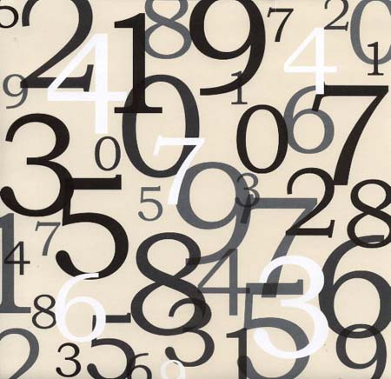

How many can you answer correctly?

Score:____

Name ____________________

Parent’s Signature ___________________
Unit 1 Practice Problems

1. Make a 14-dot array that has exactly 2 rows (Include the number model).

Example: List all of the factors of 20. 1, 2, 4, 5, 10, 20

2. List all of the factors of 48.

_________________________________________________________

3. List all of the factors of 36.

_________________________________________________________

4. List all of the factors of 100.

_________________________________________________________

5. Circle all of the even numbers. Underline all of the prime numbers.

2 4 5 7 8 9 12 14 20 21 27 29

6. Circle all of the odd numbers.

300 303 401 500 1,000 5 6 11 24 1

Example: 3² = 3 * 3 = 9

7. 9² = ___________________

8. 14² = ___________________

9. 6² + 3² = ___________________

10. 4² - 2² = ___________________

Example: 10² = 100. The square root of 100 is 10.

11. ___² = 16. The square root of 16 is ____.

12. ___² = 49. The square root of 49 is ____.

13. _____² = 1,600. The square root of 1,600 is ______.

Remember:

- All numbers are divisible by 1.
- All numbers that end in 0, 2, 4, 6, or 8 are divisible by 2.
- If the sum of a number’s digits is divisible by 3, then the number is divisible by 3.
- If a number is divisible by both 2 and 3, then it is also divisible by 6
- If the sum of a number’s digits is divisible by 9, then the number is divisible by 9.
- Numbers that end in 0 or 5 are divisible by 5.
- Numbers that end in 0 are divisible by 10.

(14 – 19) Complete the chart.

 | Divisible...
 | by 2? | by 3? | by 6? | by 9? | by 5? | by 10?

Number
35
36
90
16
235
123
Example:

Write the prime factorization for 32.
32 = (16 * 2) = (8 * 2 * 2) = (4 * 2 * 2 * 2) = (2 * 2 * 2 * 2 * 2) = 2 ⁵

20. Write the prime factorization for 24.

__________________________________________________________

21. Write the prime factorization for 45.

__________________________________________________________

22. Write the prime factorization for 32.

__________________________________________________________

23. Write a 7-digit numeral with

4 in the tens place.
6 in the hundredths place,
8 in the hundreds place,
2 in the ten-thousands place,
and 3s in all other places.

____ ____ , ____ ____ ____ . ____ ____

24. Is 333 a prime or composite number? ________________

Explain how you know: __________________________________________

______________________________________________________________

______________________________________________________________

25.
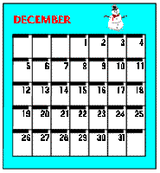
Figure out Tiffany’s birthday using the following clues.

- It is not a prime number.
- It is divisible by 5.
- It is also divisible by 4.

Tiffany’s birthday is December ____.

Unit 2 Practice Problems

1. What is the best estimate for  932.83 + 432.1? | 2. What is the exact answer for  932.83 + 432.1?
3. What is the best estimate for  192 + 399? | 4. What is the exact answer for  192 + 399?
5. What is the best estimate for  59.2 + 7.95? | 6. What is the exact answer for  59.2 + 7.95?
7. What is the best estimate for  501 – 267? | 8. What is the exact answer for  501 – 267?
9. What is the best estimate for  265.4 – 79.9? | 10. What is the exact answer for  265.4 – 79.9?
11. What is the best estimate for  17.5 – 13.71? | 12. What is the exact answer for  17.5 – 13.71?
13. Round to the nearest hundred  a. 69 __ __ __  b. 1, 659 __ , __ __ __  c. 29, 319 __ __, __ __ __  d. 625 __ __ __ | 14. Round to the nearest one  a. 308.9 __ __ __. __  b. 89.63 __ __ __. __ __  c. 3,563.45 __, __ __ __. __ __  d. 170.8 __ __ __. __
15. Round to the nearest tenth  a. 509.47 __ __ __. __ __  b. 301.09 __ __ __. __ __  c. 11.63 __ __ . __ __  d. 1,781.088 __, __ __ __. __ __ __ | 16. Round to the nearest ten  a. 592 __ __ __  b. 2,533 __, __ __ __  c. 124.92 __ __ __. __ __  d. 83.99 __ __. __ __
17. For the number 732,128, what is the value of the . . .  tens place? _____________________  ten-thousands place? _____________  ones place? _____________________  hundreds place? _________________  thousands place? ________________ | 18. For the number 563.149, what is the value of the . . .  tens place? _____________________  tenths place? ____________________  hundreds place? _________________  hundredths place? ________________  ones place? _____________________  thousandths place? _______________
19. What is the best estimate of 45 * 79? | 20. What is the exact answer for  45 * 79?
21. What is the best estimate for  13.9 * 2.15? | 22. What is the exact answer for  13.9 * 2.15?
23. What is the best estimate for  322 * 122 | 24. What is the exact answer for  322 * 122?
25, part 2. Erika’s mom tells her that for every math score of 90 or higher that she earns this winter, she will let her rent 3 video games. Erika’s scores are listed below:  67, 81, 91, 90, 72, 85, 93, 91, 95  How many video games is her mother going to rent for her? | 25, part 2. Erika is OBSESSED with data. She decides to figure out all of the important data landmarks from her math scores. Complete them below:  a. maximum ___________  b. minimum ___________  c. range ______________  d. mode ______________  e. median _____________  f. mean _______________

Unit 3 Practice Problems

Find the missing angle measures without measuring.

(Remember: A line has a measure of 180º. The sum of the angles in a triangle is also 180º).

1.
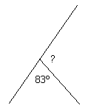 ? = _____

2.
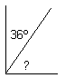 ? = ______

3.
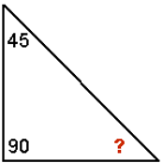 ? = ______

4.
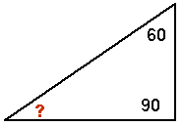 ? = ______

Label each angle acute, right, or obtuse (5, 6, 7, 8, 9, 10).

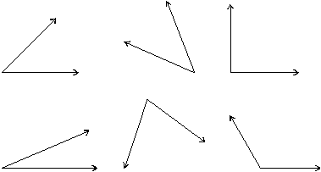

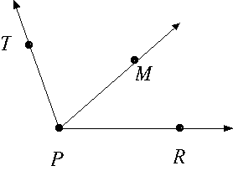

11. Write the names of the two acute adjacent angles.

______________ ______________

12. Write the name of the obtuse angle.

___________

Label the following triangles equilateral, isosceles, or scalene (13, 14, 15).

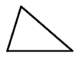

________________

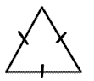

________________

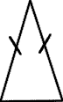

________________

16. Circle all of the polygons that have at least one set of parallel lines.
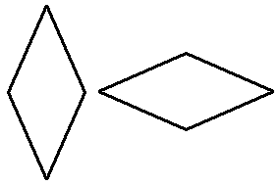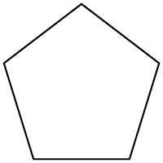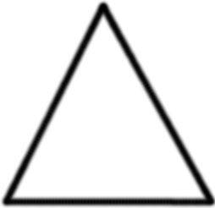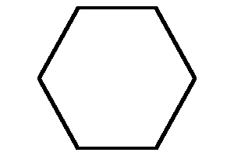
17. Cross out the pattern that does not tessellate.
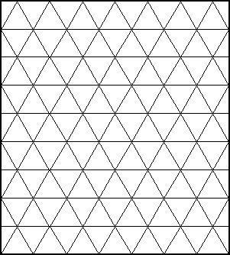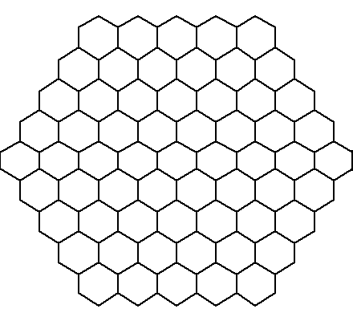

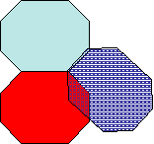

Label the following triangles right, acute, or obtuse (18, 19, 20)
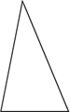
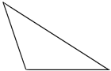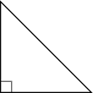

__________________ _________________ __________________

21. Circle all of the quadrangles below.
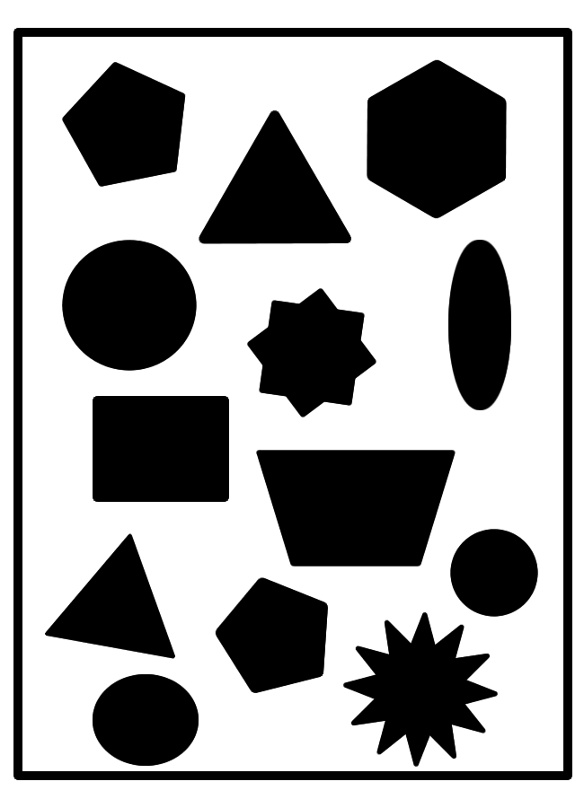
22. Draw a quadrangle with exactly one right angle.

23. Circle the shape that is a regular polygon.
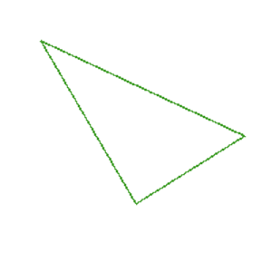

24. When it is 9:00, what type of angle do the hands of a clock form?

________________________________________________________________

25. Draw a pentagon, a hexagon, and an octagon.

Pentagon | Hexagon | Octagon

Unit 4 Practice Problems
1. What is the best estimate for  84 divided by 6? | 2. What is the exact answer for  84 divided by 6?
3. 7 * ________ = 119 | 4. 9 * _________ = 225
5. What is the best estimate for  684 / 12? | 6. What is the exact answer for  684 / 12?
7. What is the best estimate for  401 / 31? | 8. What is the exact answer for  401 / 31?
9. What is the best estimate for  112.8 / 6? | 10. What is the exact answer for  112.8 / 6?
11. What is the best estimate for  1,026 / 3? | 12. What is the exact answer for  1,026 / 3?
13. What is the best estimate for  $12.75 / 17? | 14. What is the exact answer for  $12.75 / 17?

15. Create a difficult long division problem and estimate the answer below. | 16. What is the exact answer for your division problem?
17. There are 150 students in grade 5. There are only 5 tables in the lunchroom available. How many students will need to sit at each table? | 18. There are 312 players in the National Basketball Association (N.B.A.) If there are 26 teams in the N.B.A., how many players are there on each team?
19. Cassandra, Fatima, Amaris, Leandra and Leticia earn $125.75 cents after collecting cans. How much money should they each receive if they share the money? | 20. Genesis, Carlos, Jose, Nathaly, and Francina collect $131.60 in cans. If each can earns them $.05, how many cans did they collect altogether?

21. Grade five is loading up buses for their end of the year trip. There will be 139 students attending. Each bus will hold 22 students. How many buses will PS 128 need to hold all of these students? Hint: your answer should be an exact number, and no students should be left behind! | 22. Compact discs are on sale for $12 each. You have $50 that your grandmother just gave you for Christmas. How many CDs can you purchase with the money you have?
23. Jahani is a reading machine. She reads an average of 38 minutes a night, every day of the week. How many minutes does she read in 60 days? Hint: this is not a division problem! | 24. Darren decides to have a big party. He spends $12.34 on decorations, $39.75 on food, and $15.01 on drinks. His mom gives him four twenty-dollar bills to pay for everything. How much money does he get back? Hint: this problem will take multiple steps to solve!
25. Create and solve your own story problem in the space below.

