The Box in the Barn

by Barbara Eckfeld Conner
Jason heard his mom calling him. Instead of answering her, he slipped deeper into the tall weeds behind his house. He closed his eyes, thinking of what he had done.
He had gotten up that morning in a good mood. Raspberry pancakes were on the table when he walked into the kitchen rubbing his eyes and yawning.
"After breakfast, Jason, I want you to go into town with me," Mom said quietly. "It's your sister's birthday, and we need to shop for her gifts."
Jason was eager to go, even if the gifts weren't for him. Buying presents was always fun.
As they drove to town, Jason couldn't help but ask the question that had been on his mind since yesterday when Aunt Nancy came. "What's in the big box that Dad took to the barn, Mom? Is it something Aunt Nancy bought for Megan's birthday?"
"It's a surprise, Jason, and I don't want you going near that barn today. Do you hear me?"
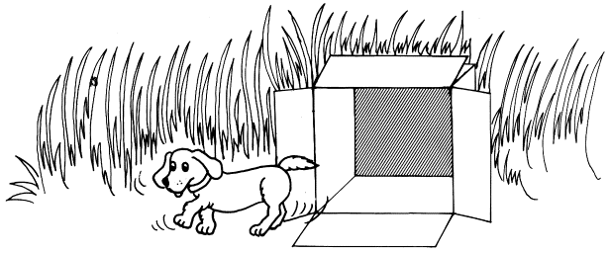
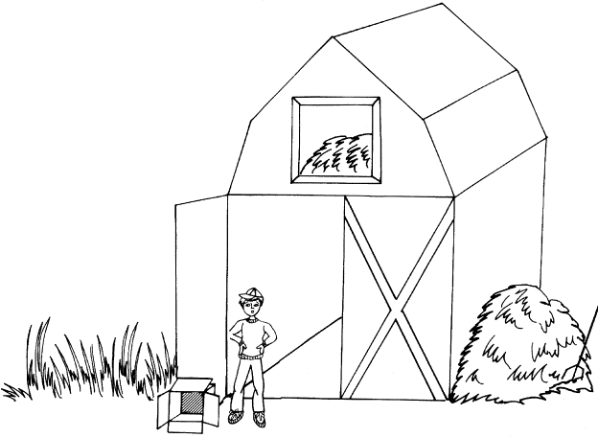
Jason sat staring at the road ahead. He knew that nothing would change her mind. Only now he was more curious than ever!
Back home, Megan ran out to meet Jason, her eyes wide and excited. "Jason, Jason, I'm six years old!" she cried, jumping up and down.
"I know, I know." Jason gave her a big hug.
Soon the house was buzzing with excitement. Megan sat on the stool watching while Mom and Aunt Nancy prepared the birthday dinner. Dad wouldn't be back for at least two hours. Jason wandered outside trying to think of something to do, but his thoughts kept returning to the box in the barn.
He started walking toward the barn, not at all sure what he'd do when he got there. He was hoping for just a glimpse of the box. Instead he heard a strange noise coming from inside the barn. He wished he could just turn back to the house, but his legs carried him into the barn. Jason saw the box. It was sitting between two bales of hay. He could hear loud wailing cries. Leaning over, Jason carefully lifted the lid. There was the most cuddly puppy he had ever seen!
"You must be pretty scared, huh, fellow?" Jason said quietly as he held the wiggly dog. "Megan's going to love you!" He secretly wished the puppy was for him. After all, Mom and Dad knew that he had been wanting his own puppy. Probably Aunt Nancy didn't know that, and anyway Megan would be happy.
Soon Jason was playing happily with the puppy, and he forgot that he wasn't supposed to be in the barn. Taffy, their big brown horse, stuck his head in the window as if to say, "What's going on?" Jason jumped, remembering that he wasn't supposed to be there. The puppy ran off as fast as it could out of the barn and into the field.
Jason stumbled out of the barn looking wildly for any trace of the puppy. "Come on, puppy! Oh, please come here!" he called, his eyes welling up with tears.
Now here he was, two hours later, hiding in the weeds. He'd looked everywhere, but the puppy was gone. He had ruined his sister's birthday.
"Jason! It's time for dinner!" Mom called even louder now. Just when he was determined to stay forever in the tall weeds, he heard his sister's voice.
"Jason! It's time for my party, Jason!" Megan yelled excitedly.
Jason rubbed his swollen eyes, trying to look normal. He couldn't ruin everything for her. "I'm here, Megan," he called.
"Are you OK?" she asked with genuine concern.
"Sure. Let's hurry." Jason grabbed her hand as they ran back.
As soon as they reached the house, the party began. Jason tried to pretend that everything was fine. When it was time to open Megan's birthday gifts, he sat in the big easy chair, hoping no one would notice him. Finally the last present was open.
"I'll be right back," Dad said.
Jason knew Dad was going to the barn. Megan would probably never forgive him for losing her birthday puppy. Everyone, even Aunt Nancy, would be angry when they found out the puppy was gone.
"Jason! Come here!" It was Dad calling from the front yard.
Jason slowly got out of the chair. It was hard to move, but Megan grabbed his hand and said, "Come on, Jason! Let's see what Dad wants."
Jason followed Megan out the door. Mom and Aunt Nancy followed close behind.
There was Dad standing with the box next to him in the grass. "Jason, I want you to open this box and see what's inside."
Jason looked up and saw that Dad was smiling. He turned and saw that Mom, Aunt Nancy, and Megan were smiling, too. What would he say to them when there was nothing in the box? But as Jason looked down, expecting to see nothing at all, he jumped back in surprise. The puppy looked up at him with sleepy eyes.
"Wow!" said Jason, bewildered.
"The puppy's for you, Son," his father said.
"I thought you'd like a gift, too, even if it isn't your birthday," said Aunt Nancy, laughing.
Megan started clapping. "Isn't he wonderful, Jason?" The puppy jumped up, ready to play. Jason and Megan spent the rest of the day with the puppy.
Later, when he was getting ready for bed, Jason turned to his father and said, "You know, Dad, I feel bad about something I did today."
Dad waited patiently as Jason explained what had happened. "And I still can't figure out how my puppy got back into his box!" he added.
"Well, Son, on my way home I saw your puppy running along the side of the road. I figured he had gotten out of his box somehow...You must have felt terrible during the party," Dad continued. "I get the feeling you've learned a lot today." He pulled back the covers on Jason's bed.
Jason looked down at his new puppy, who was sleeping soundly in a basket by the bed. "Dad, I think I'll call him Buddy."
Dad smiled and tucked the covers snugly around Jason.

1. | Which best describes Jason's father?
 | A) | Strict and unwilling to listen to Jason
 | B) | Understanding and patient with Jason
 | C) | Curious and puzzled by the empty box
 | D) | Angry and sad that Jason hid

2. | Jason's problem could have been prevented if
 | A) | his mother had not warned him to stay away from the barn
 | B) | he had not let the puppy play along the road
 | C) | his curiosity had not led him to open the box
 | D) | he had not wanted a puppy of his own so badly

3. | Why did Jason not answer when his mom called him for dinner?

4. | Jason probably would have felt better at the birthday party if
 | A) | the box had been put in the backyard
 | B) | the puppy had not run out of the barn
 | C) | the party had lasted longer
 | D) | he had not hidden in the tall weeds

