The Bundle of Sticks
Illustrated by Michael Chan
A father had a family of sons who were always quarreling (arguing) among themselves. When he failed to heal their disputes, he decided to give them a practical illustration of the evils of disunion; and for this purpose he one day told them to bring him a bundle of sticks.
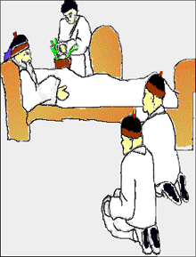
When they had done so, he placed the bundle into the hands of each of them in succession, and ordered them to break it in pieces. They tried with all their strength, and were not able to do it.
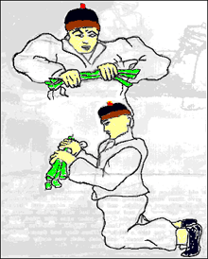
He next opened the bundle, took the sticks separately, one by one, and again put them into his sons' hands, upon which they broke them easily.
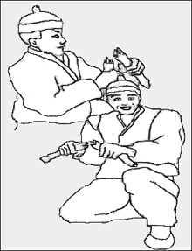
He then addressed them in these words: "My sons, if you are of one mind, and unite to help each other, you will be as this bundle, uninjured by all the attempts of your enemies; but if you are divided among yourselves, you will be broken as easily as these sticks."
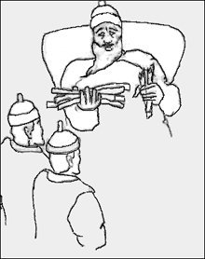
Union gives strength.

- At the beginning of the fable, the brothers are constantly

A arguing with their father.
B picking up sticks.
C helping one another.
D arguing with one another.

- The father asks his sons to bring him sticks because

A he wants to build a fire.
B he wants to show how strong he is by breaking them.
C he wants to show them what is wrong with disunion.
D he wants them to work together and build something with the sticks.

- The sons are only able to break the sticks once

A the sticks are separated from one another.
B the sticks are tied into a bundle.
C they agree to get along.
D they dip the sticks in the river.

The Fox and the Stork
Illustrated by Jason Donati
At one time the Fox and the Stork were on visiting terms and seemed very good friends. So the Fox invited the Stork to dinner, and for a joke put nothing before her but some soup in a very shallow dish. This the Fox could easily drink up, but the Stork could only wet the end of her long bill in it, and left the meal as hungry as when she began.
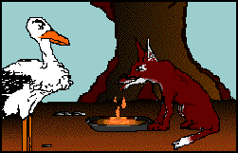
"I am sorry," said the Fox, "the soup is not to your liking."
"Please do not apologize," said the Stork. "I hope you will return this visit, and come and dine with me soon."
So a day was chosen when the Fox should visit the Stork; but when they were seated at table all that was for their dinner was contained in a very long-necked jar with a narrow mouth, in which the fox could not insert his snout, so all he could manage to do was to lick the outside of the jar.
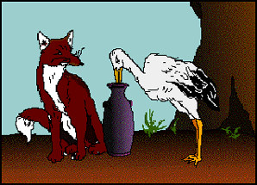
"I will not apologize for dinner," said the Stork...
One bad turn deserves another.

- In the beginning of the fable, the Fox invites the Stork over for

A a snack
B lunch
C a movie
D dinner

- According to the passage, the Stork is hungry when she leaves the Fox’s home because

A it says she “left the meal as hungry as when she began.”
B she did not like the food the Fox offered her.
C the soup was in a very shallow dish, which she was not able to drink from.
D storks do not eat soup.

- When he goes to the Swan’s home for dinner, the Fox does not eat anything because

A he licks the outside of the jar.
B he wants to get back at the Swan.
C he cannot fit his snout into the jar containing the food.
D he has already eaten.

