Holidays In The United States
There are no official holidays for the whole United States. The U.S. government decides which days will be federal holidays. (These are really just for Washington, D.C.) Each state picks its own holidays, but most states celebrate the ones listed here. On these holidays, most banks and schools are closed, and so are many offices. Washington's Birthday (or Presidents' Day), Memorial Day, and Columbus Day are usually celebrated on the nearest Monday.

World Almanac for Kids

New Year's Day
The U.S. and most other countries celebrate the beginning of the new year on January 1.

Martin Luther King, Jr. Day
Observed on the third Monday in January, this holiday marks the birth (January 15, 1929) of the African-American civil rights leader Rev. Martin Luther King Jr. In 2006, it will be celebrated on January 16.
Washington's Birthday or Presidents' Day
On the third Monday in February (February 20, 2006) most states celebrate the births of both George Washington (born February 22, 1732) and Abraham Lincoln (born February 12, 1809).
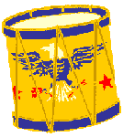
World Almanac for Kids

Memorial Day or Decoration Day
Memorial Day, observed on the last Monday in May (May 29, 2006), is set aside to remember men and women who died serving in the military.

Fourth of July or Independence Day
July 4 is the anniversary of the day in 1776 when the American colonies signed the Declaration of Independence. Kids and grownups celebrate the event with bands and parades, picnics, barbecues, and fireworks.

World Almanac for Kids
Fireworks commemorate the Fourth of July in the United States

Labor Day
Labor Day, the first Monday in September, honors the workers of America. It was first celebrated in 1882. It falls on September 5 in 2005 and September 4 in 2006.
Columbus Day
Celebrated on the second Monday in October, Columbus Day is the anniversary of October 12, 1492, the day when Christopher Columbus was traditionally thought to have arrived in the Americas (on the island of San Salvador). It falls on October 10 in 2005 and October 9 in 2006.
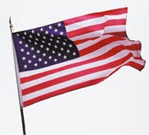
World Almanac for Kids
U.S. Flag

Election Day
Election Day, the first Tuesday after the first Monday in November (November 8 in 2005 and November 7 in 2006), is a holiday in some states.

Veterans Day
Veterans Day, November 11, honors veterans of wars. First called Armistice Day, it marked the armistice (agreement) that ended World War I. This was signed on the 11th hour of the 11th day of the 11th month of 1918.
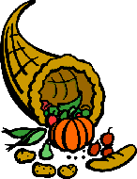
World Almanac for Kids
The cornucopia or horn of plenty is a symbol of Thanksgiving

Thanksgiving
Thanksgiving was first observed by the Pilgrims in 1621 as a harvest festival and a day for thanks and feasting. In 1863, Abraham Lincoln revived the tradition. It comes on the fourth Thursday in November--November 24 in 2005 and November 23 in 2006.

Christmas
Christmas is both a religious holiday and a legal holiday. It is celebrated on December 25.
Citation: "Holidays: Holidays In The United States" The World Almanac for Kids, Facts For Learning. http://factsforlearning.2facts.com
- The author wrote this passage mainly to

A persuade the reader to celebrate many holidays.
B entertain the reader.
C inform the reader about holidays in the United States.
D show the reader how to celebrate holidays in the United States.

An Eye for Video Games?

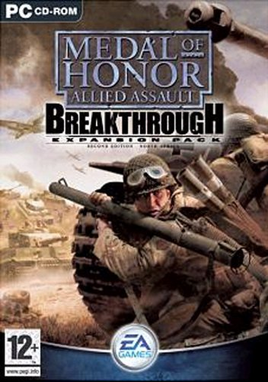
For years, experts have said that video games are bad for you. Now comes the news that playing video games might actually be a good thing.

Researchers at the University of Rochester, located in upstate New York, have discovered that playing action-packed video games improves certain visual skills-skills that might come in handy when driving a car.

Researchers based their findings on tests of men 18 to 23 years old. The scientists looked at the ability of each person to identify, count, and track shapes flashing on a cluttered screen.

Researchers found that the men who played an action-packed video game called Medal of Honor, in which players kill the enemy who run through doors or move from behind buildings, had better visual skills than those who did not play the game.

The video-game players were able to pick out objects in a cluttered area better than those who didn't play the game.

"[They] had the ability to monitor the environment for new information, like the ability to notice a dog running down a driveway while you're driving on a crowded street," researcher C. Shawn Green told The Hartford Courant.

In addition, researchers found that people who did not usually play video games developed better visual skills after being trained to play.
The research could benefit people who have suffered brain damage or those who have lost parts of their vision, the researchers say.

Green and his co-researcher, Daphne Bavelier, say that nonviolent games would have worked just as well for the study, as long as the games demanded that the player have quick reflexes.

Still, many experts say that playing action-packed video games-such as Medal of Honor-are bad for children. They say the games rob kids of time spent with friends, playing sports, and doing homework.

Children who sit for hours playing video games are more likely to be overweight than children who are involved in physical activity, some researchers say. And worse, they say, video games encourage violent behavior.

Citation: "An Eye for Video Games?." Weekly Reader Senior, 17 October 2003. Facts for Learning <http://factsforlearning.2facts.com>.

- The author most likely wrote this passage to

A entertain the reader by reminding them about how fun it is to play video games.
B persuade the reader that playing video games is actually good for kids.
C persuade the reader that playing video games is actually bad for kids.
D inform the reader about some of the pros and cons of playing video games.

- The passage would best fit into the category of

A functional document
B informational passage
C story
D poem

