1-2-3 Make A Papier Mache Mask!

The art of making decorative objects from paper and glue is called papier-mache , which means "chewed paper" in French. The French used this technique in the 1500s to make dolls' heads. Much earlier, around 200 BC , the Chinese used this technique to make warrior helmets, which they coated with lacquer for strength. Today, papier-mache is used to make objects such as masks, dolls, tables, chairs, vases, puppets, and piñatas. It's easy and fun. Find out for yourself by making your own papier-mache mask.
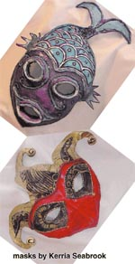
Kerria Seabrook
Completed
papier-mache masks

What You'll Need
- glue
- newspaper
- water
- balloon
- brush
- paints
- tissue paper
- scissors
- black marker (soft point)
- ribbon or elastic
- tape
- a piece of heavy cardboard
- stapler

Step 1
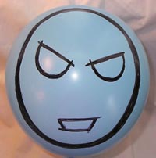
Kerria Seabrook
Step 1
Blow up the balloon to about the size of your head and use the marker to draw a mask outline on the balloon. Tape the balloon to the cardboard. Mix one part water and two parts glue in a bowl. Tear (don't cut) the newspaper into strips about the size of your fingers.
Be sure to put lots of newspaper under your project so you don't make a big mess!

Step 2
Dip a strip of newspaper into the glue mix. Get it good and wet, and then place it on the balloon inside the outline of your mask. Don't cover up the eyes or the nose. Keep applying strips until your outline is filled in. When you are done you should have three to five layers over the entire mask. Smooth out any bubbles or wrinkles with your fingers.
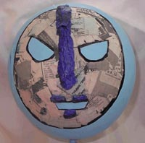
Kerria Seabrook
Step 2
Don't worry if you don't follow your outline exactly -- you can always trim the mask with scissors after it has dried. You can build up areas and details using pieces of cardboard or tissue paper soaked in glue.

Step 3
Let the mask dry for at least a day. When it's all dry, snip a small hole in the balloon right next to the knot and let the air out. The mask will pull away from the balloon and you can trim off any rough edges. Now you can paint and decorate the mask. (Be sure to leave a quarter of an inch on each side to staple the elastic or ribbon, so you can wear the mask when you're done.) Any kind of water-based paint will work.
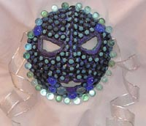
Kerria Seabrook
You can add feathers, beads, macaroni, beans, yarn, sequins, string, fabric, marbles, aluminum foil, or buttons. The possibilities are endless!
Citation: "Art: 1-2-3 Make A Papier Mache Mask!" The World Almanac for Kids, Facts For Learning. http://factsforlearning.2facts.com

- The author wrote this passage in order to

A explain the steps for making a Papier Mache mask.
B entertain the reader by explaining how Papier Mache is done.
C describe a Papier Mache mask.
D inform the reader about the importance of this artistic tradition.

- The author probably entitled this passage “1-2-3 Make a Papier Mache Mask” in order to show that

A you can have fun when making a Papier Mache mask.
B you should make a Papier Mache mask immediately.
C you can make a Papier Mache mask in three easy steps.
D at least three people can make a Papier Mache mask.

- The author of this passage would probably agree that

A Papier Mache is an art of the past that has no place in our modern world.
B Papier Mache is tedious and difficult.
C Papier Mache is only for people who consider themselves to be artistically talented.
D Papier Mache is for anyone who wants to give it a try.

