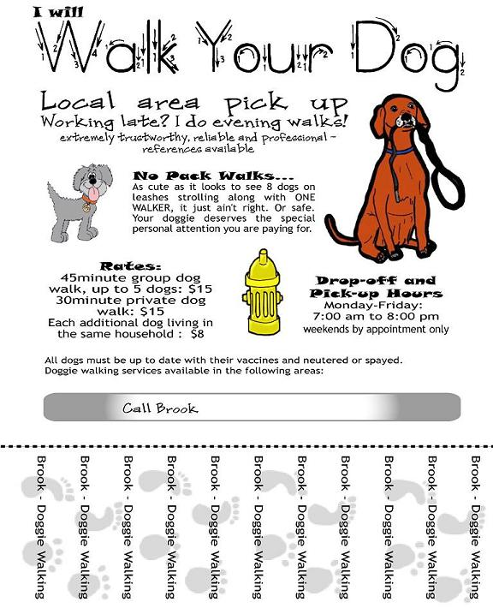

- The author says, “extremely trustworthy, reliable, and professional,” to show that

A she deserves to get paid well for walking her customers’ dogs.
B she should have a good job.
C she can be trusted to take good care of her customers’ dogs.
D she is not only a good dog-walker, but also a good friend.

- The author writes, “As cute as it is to see 8 dogs on leashes strolling along with ONE WALKER, it just ain’t right” to show that

A she does think that dogs are extremely cute.
B she is informal and easy-going when dealing with dogs.
C she does not agree with walking so many dogs at once.
D she would prefer to admire dogs from afar instead of having to walk them.

- The author mainly created this flyer to

A entertain the reader.
B persuade the reader to hire her.
C inform the reader about dog-walking.
D persuade the reader to pay her well.

